**Day 4 - Dynamic Frontend Components – Nike Shoes**

**Introduction:**

On Day 4, focus on designing and dynamically frontend components for the shoes marketplace. The goal was to enhance the user experience by integrating data from sanity CMS and creating scalable and reusable components.

**Key Objective:**

* Building dynamic frontend components to display data from Sanity CMS.
* Implementing reusable and modular components.
* Understanding state management techniques.
* Applying responsive design and UI/UX best practices.

**Components Developed:**

* **Product Listing Component:** Displayed products dynamically in a grid layout shows product name, price.

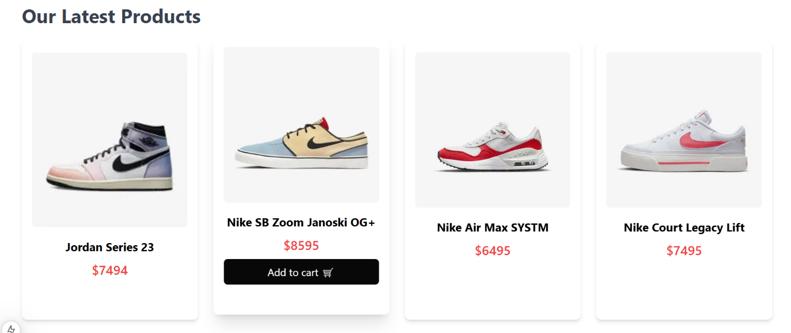

* **Product Detail Component:** Provided details about the product name, description, price, category, color. Dynamic routing ensures each product has a unique URL for easy sharing.

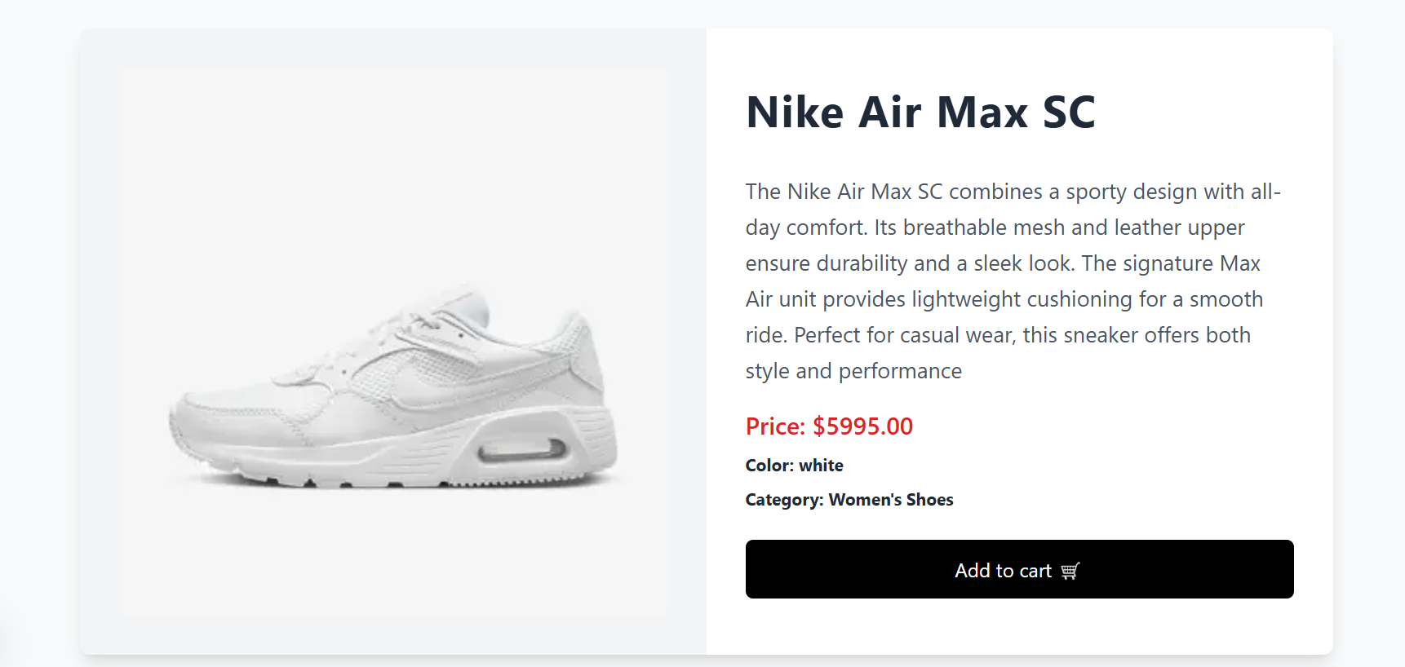

* Search Bar Component

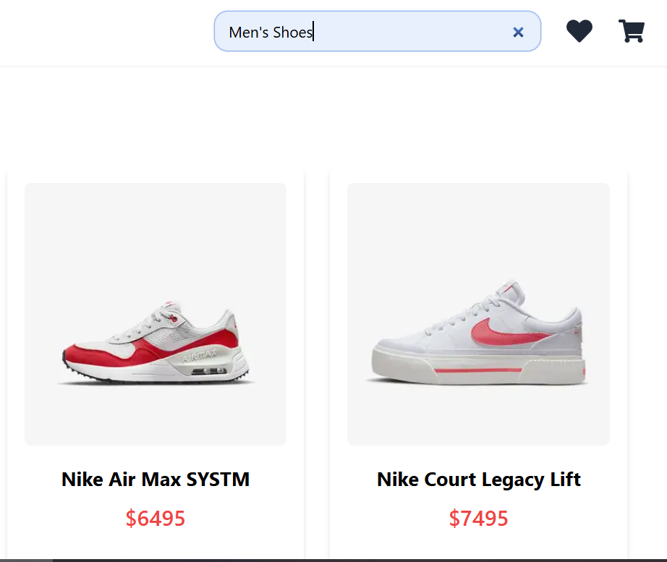

* **Add to Cart:**

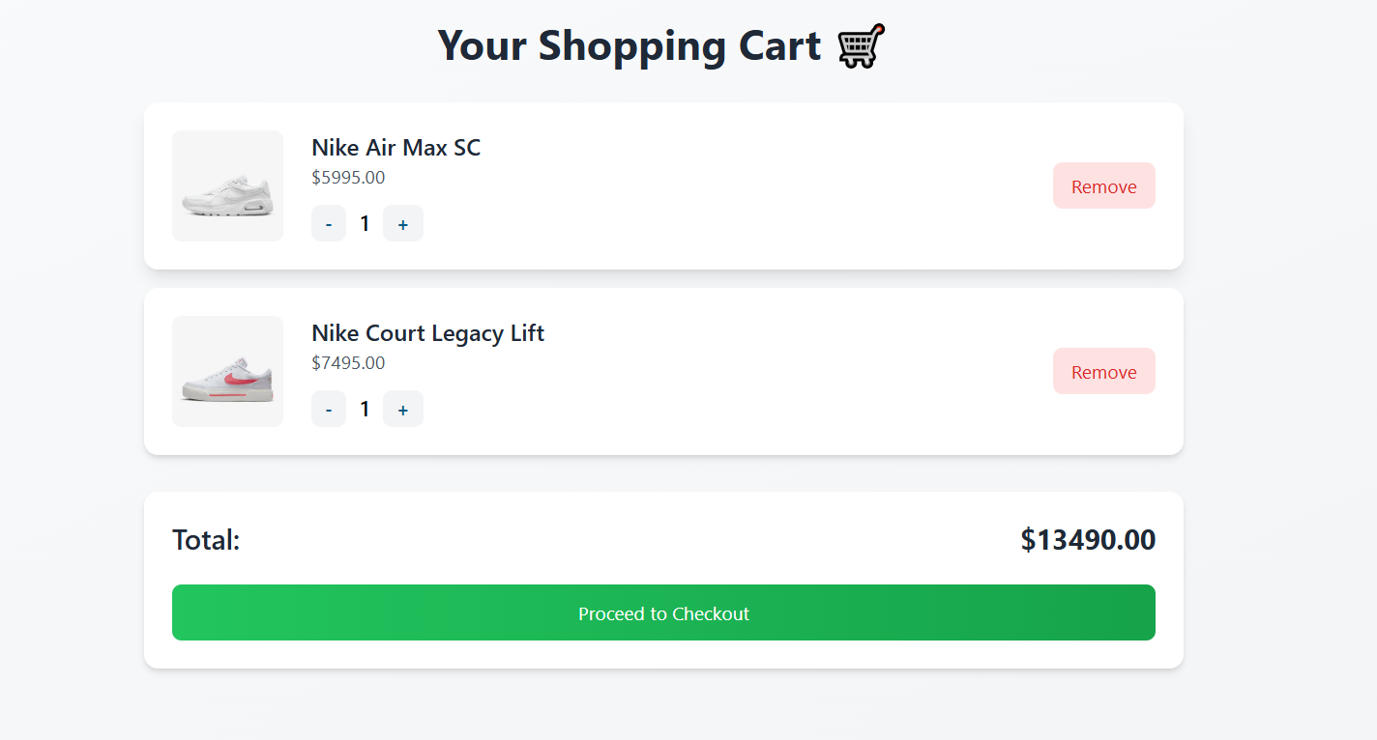User can add products to the cart, view them, and remove items dynamically.

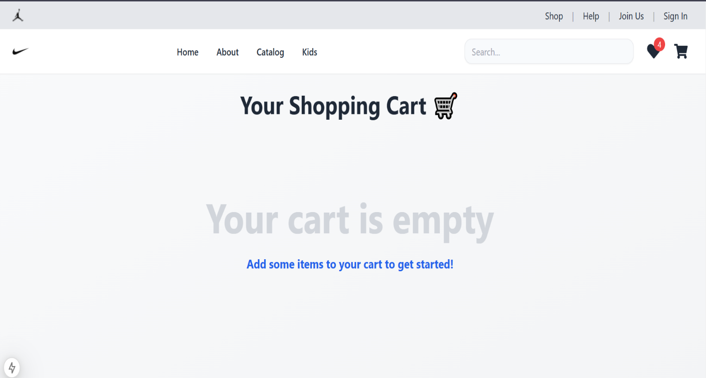

* **Wishlist:**

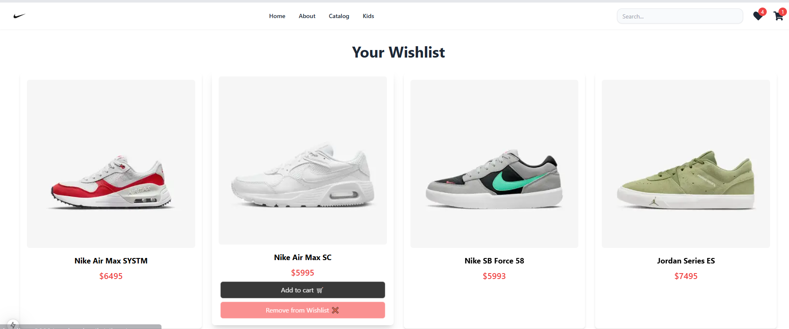User can add product to the wishlist view them, and remove items dynamically.

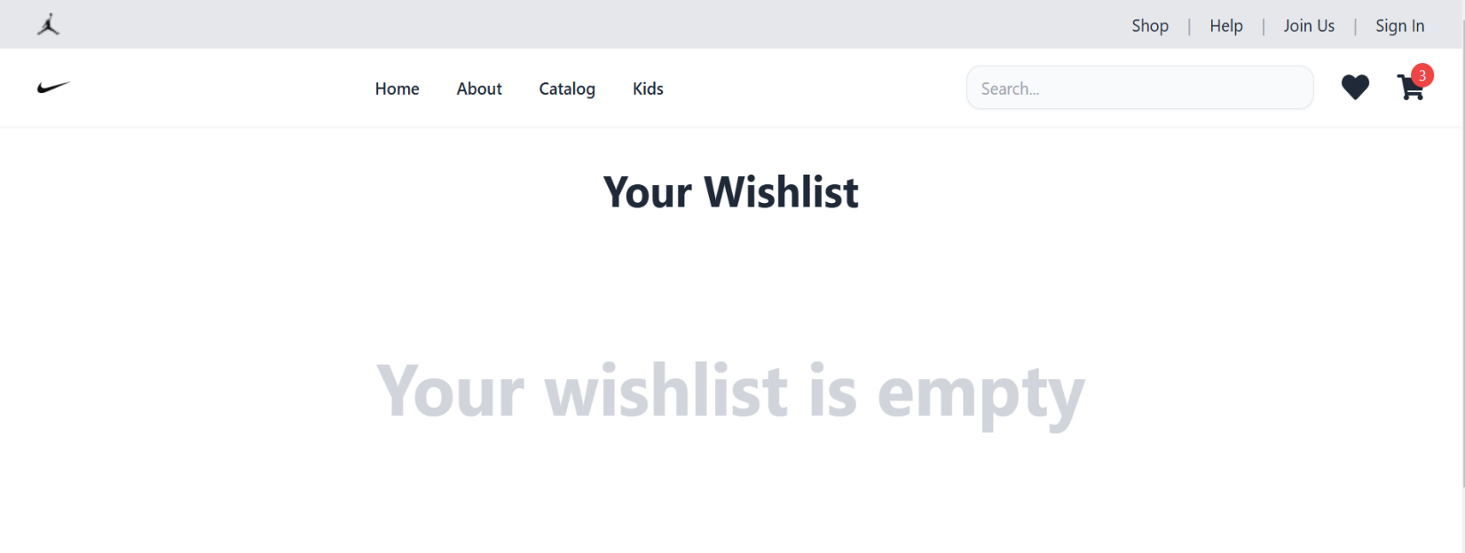

**Checkout:**

User can enter their delivery information, choose a payment method, and confirm their order to complete the purchase.

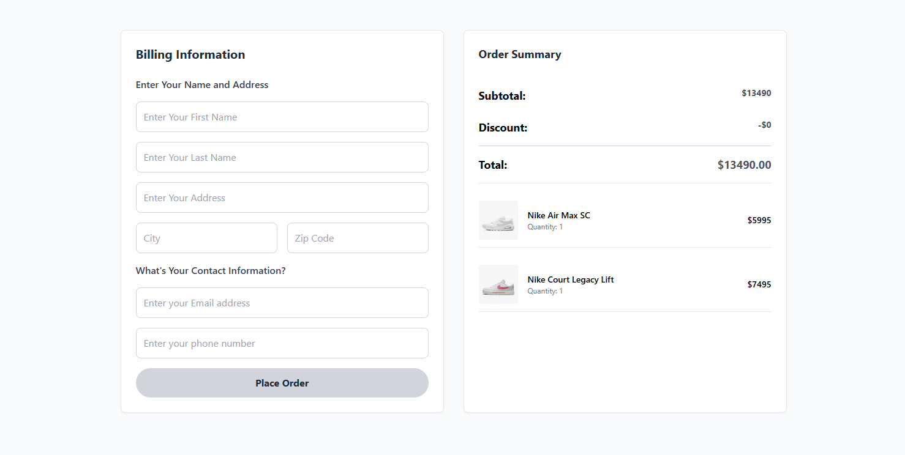

**Code Snippets:**

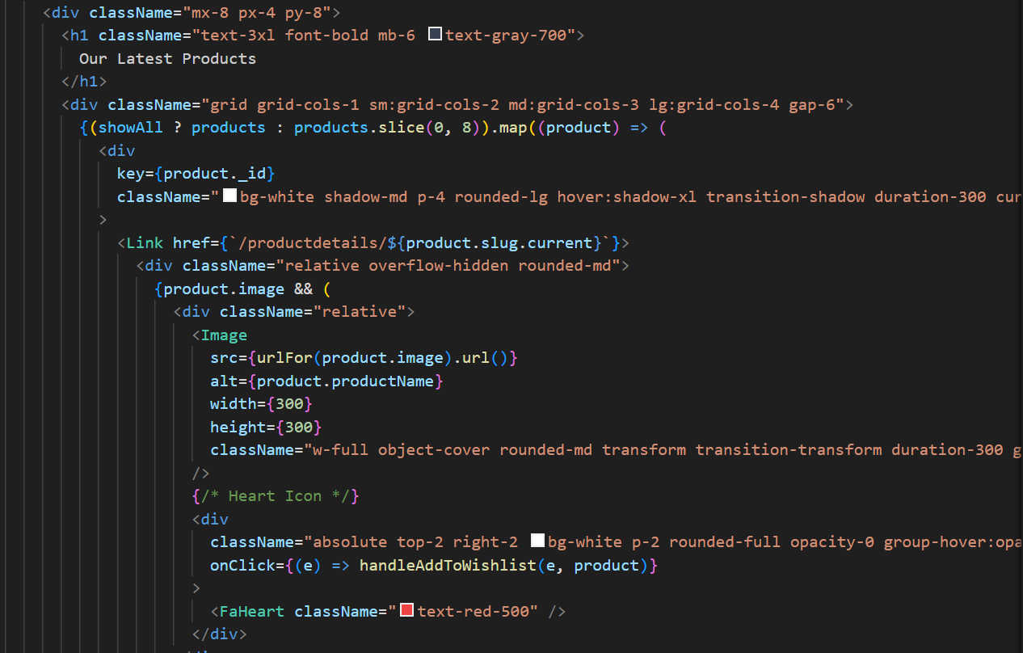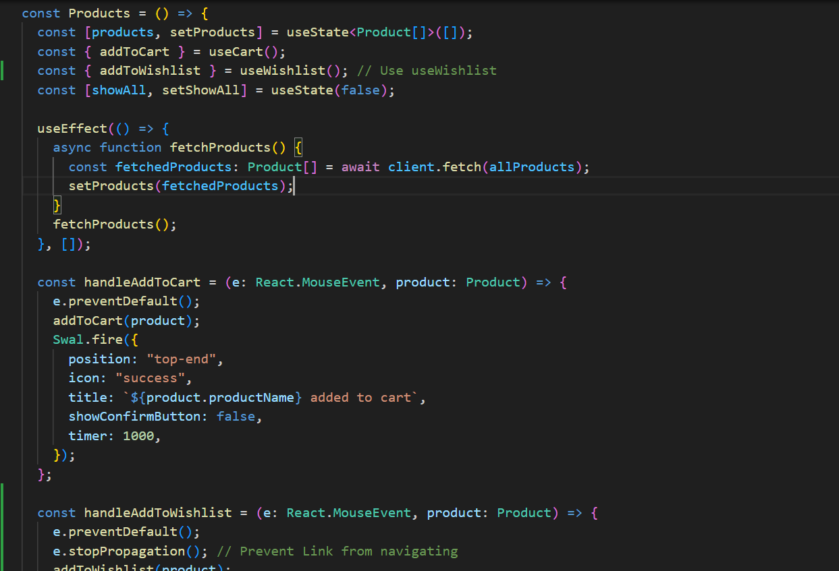**Product Listening Page:**

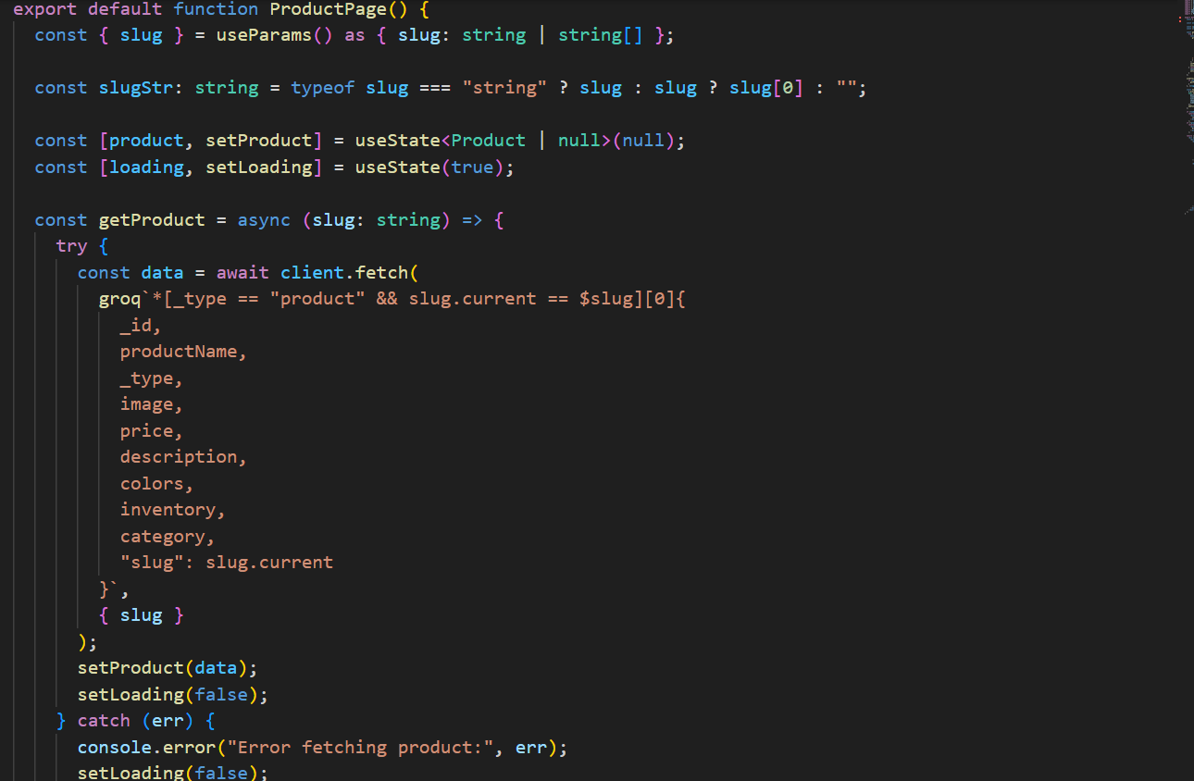**Product Details Page:**

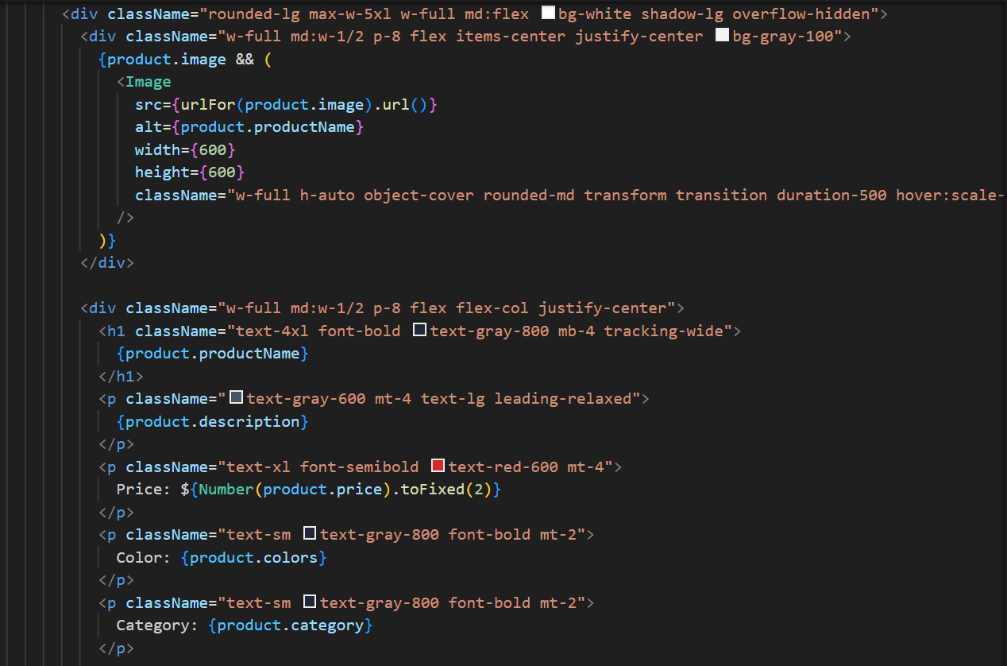



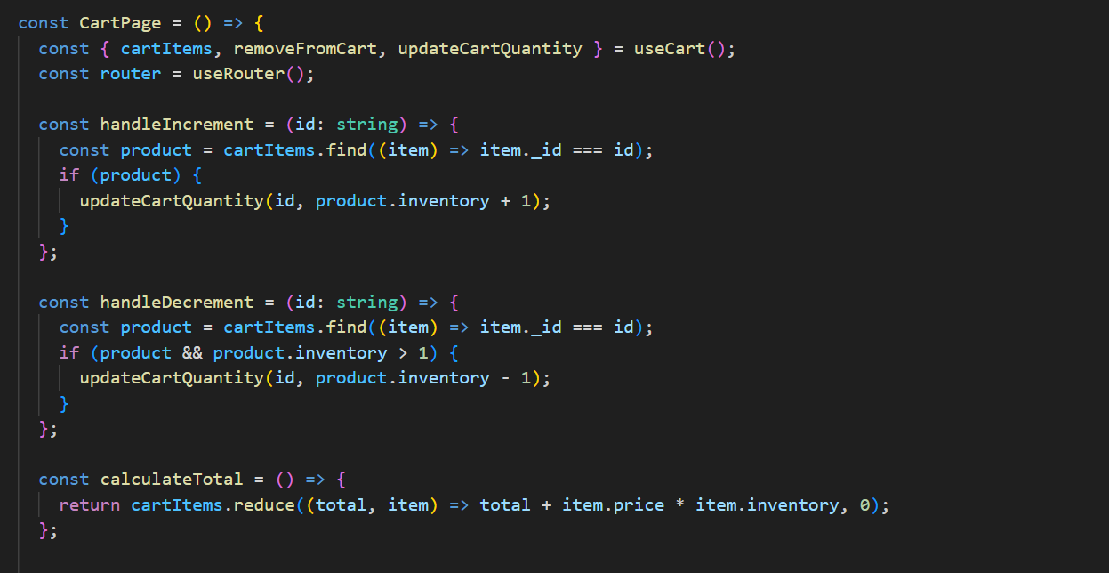**Cart Page:**

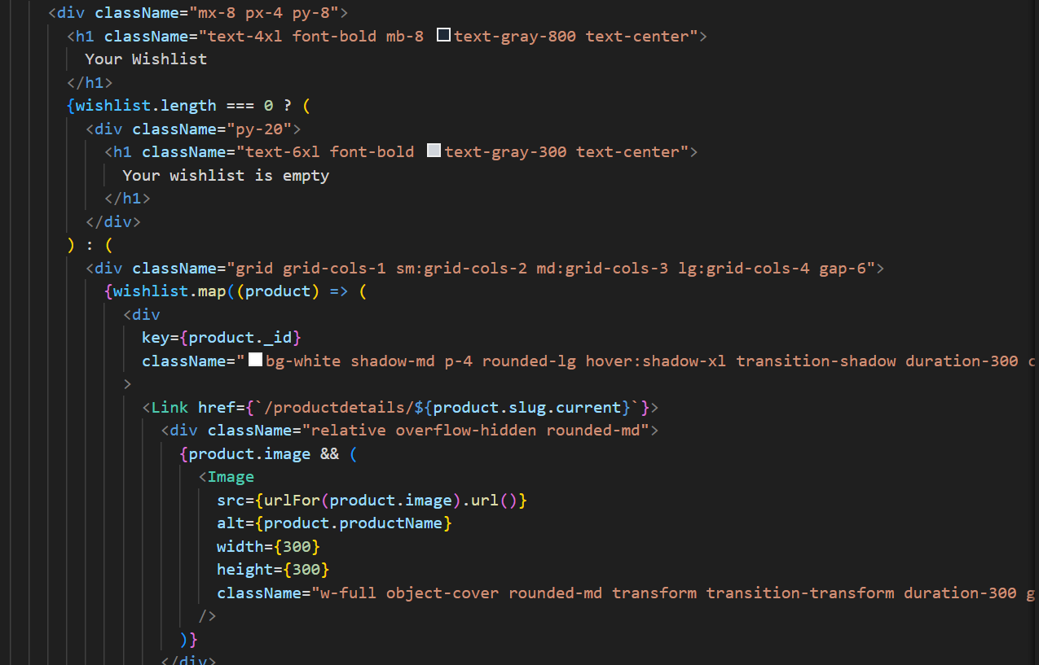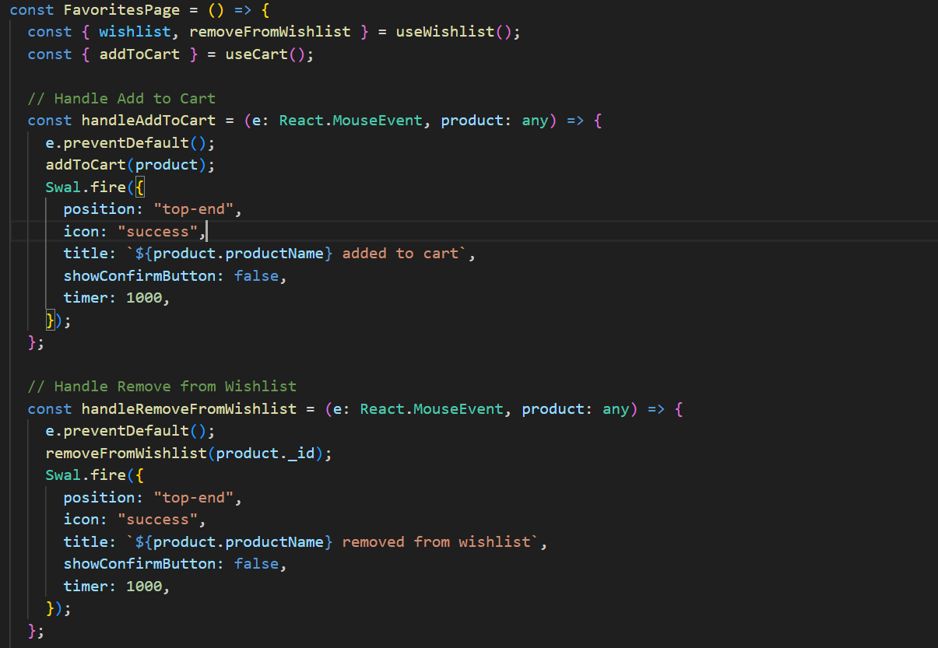**Wishlist Page:**

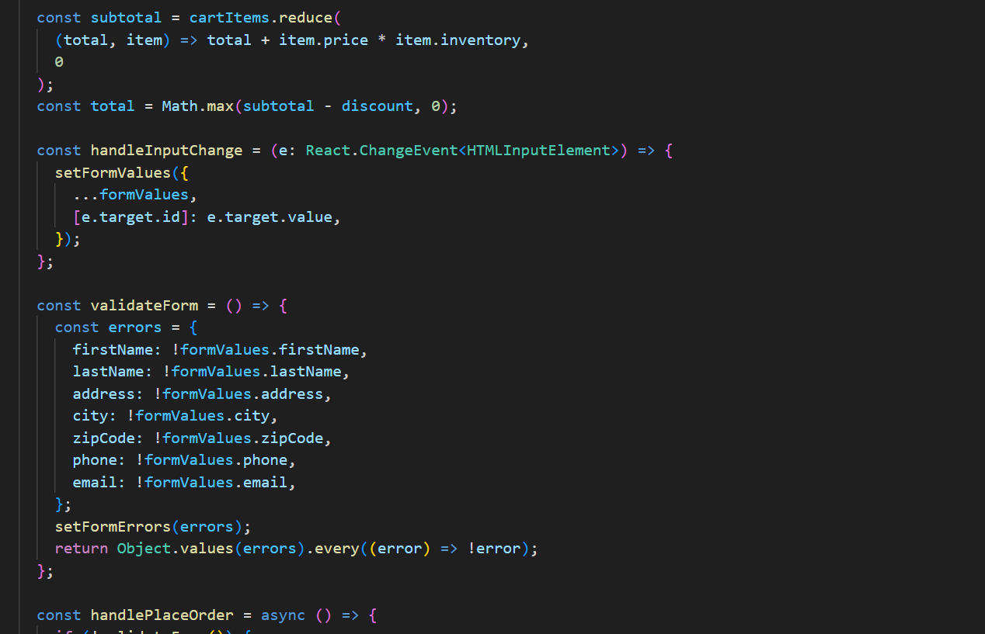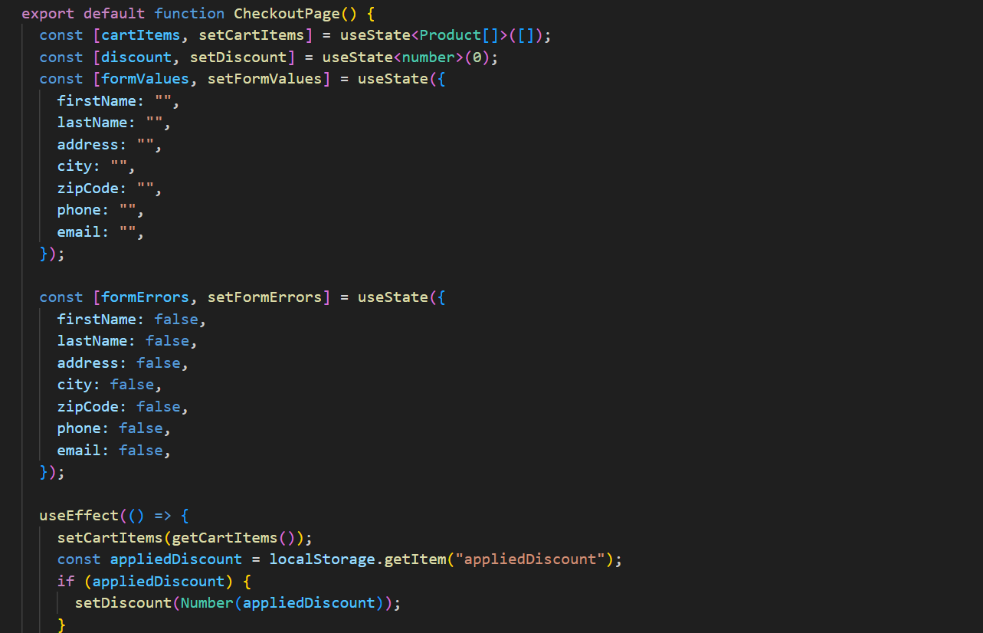**Checkout Page:**